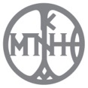

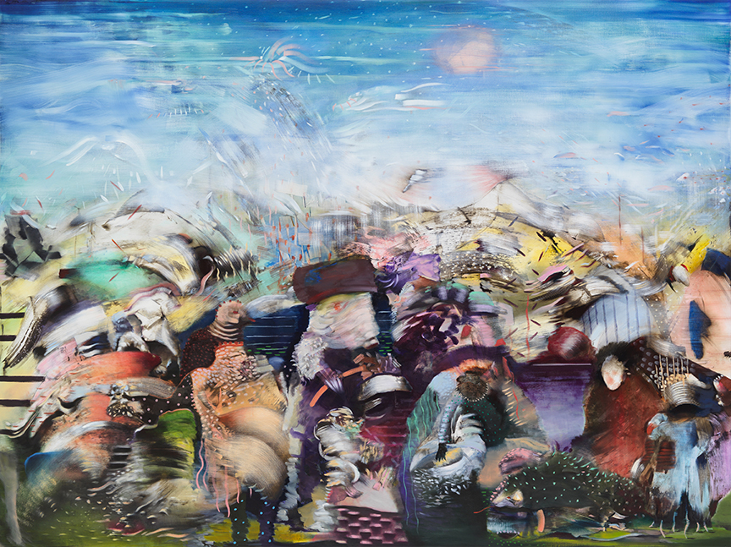

**Ali BANISADR**

**ULTRAMARINUS**

**Beyond the sea**

## Benaki Museum of Greek Culture

4 November 2020 –10 January 2021

Press kit:

PRESS RELEASE

The Benaki Museum is hosting **Ali Banisadr’s first solo exhibition in Greece** **entitled *Ultramarinus – Beyond the Sea***, at the Spyridon & Eurydice Costopoulos Gallery, Museum of Greek Culture, curated by Polina Kosmadaki, Curator of Modern and Contemporary Art and Head of the Benaki Museum Paintings, Drawings and Prints Department.

The exhibition title refers to Ultramarine, the blue colour pigment used as early as the Middle Ages, which was originally extracted from the gemstone lapis lazuli and is believed to encapsulate all shades of water and skies. Artists such as Kandinsky associated Ultramarine with the awakening of the transcendental element. Moreover, in Eastern philosophy, this colour is linked to the sixth chakra (or “third eye”), the awakening of “elevated consciousness”.

The religious, cultural and supernatural connotations of such a unique colour are crucial to Banisadr’s expressive works, in which interrelations with ancestral forms of painting are consolidated. In this exhibition, the dialogue between key works of the artist’s oeuvre and Islamic and Chinese ceramics of the Benaki Museum collections serves as a foothold for projecting the past onto the present. The free associations of forms, sources and various narratives are driven by this powerful colour which dominates Banisadr’s ardent landscapes. In particular, a section of the exhibition features works in blue and white, which act as a kind of essay on the symbolism and “magical” properties of the colour blue.

**Ali Banisadr** was born in Tehran, Iran and lives and works in Brooklyn, New York. He is an internationally established contemporary painter who recently exhibited at the Metropolitan Museum of Art in New York. Ali Banisadr’s perception of sound is inextricably linked to color and form. His shapes, figures and colour contrasts draw on childhood memories of his native Tehran: the sound of explosion and conflict permeates his densely populated landscapes in ways that evoke the turbulence of the Iran-Iraq war.

Banisadr’s apocalyptic-like views oscillate between the recent neo-figurative tendencies in painting and the reference to a sci-fi future of hybrid machine-like creatures. He works with complex intertwining forms and shapes that generate a visual narrative made of chromatic fields, gestural brushstrokes and a variety of historical references. Drawing from different art historical sources such as miniature painting, Abstract Expressionism, Bruegel, Hieronymus Bosch but also Futurism, Surrealism and Chinese landscape painting, he composes narrative landscapes that encompass more than a story: a feeling of explosion, revelation and tumult emanates conveyed by the disruption of compositional balance and the organisation of space. The density of the elements, the attention to detail, the juxtaposition between the figurative and the abstract and the large-scale of his artworks contribute to creating areas that hover between reality and fantasy while allowing space for the viewer to be drawn in.

This historical aspect of Banisadr’s work, the universality of his references and the interaction between western art and ancestral forms of the East reveal the affinity of the exhibited works with the Benaki Museum’s permanent collections.

**RECENT EXHIBITIONS**

Ali Banisadr has a solo-exhibition currently on view at the Wadsworth Atheneum Museum, Hartford, CT and he has forthcoming exhibitions at the Museo Stefano Bardini and the Palazzo Vecchio, Florence, Italy in 2021. Solo and two-person exhibitions of his work were recently held at the Gemäldegalerie museum, The Academy of Fine Arts, Vienna, Het Noordbrabants Museum, Den Bosch, Netherlands and at the Museum of Contemporary Art, Jacksonville, FL. In 2013, his work was included in “Love Me/Love Me Not, Contemporary Art from Azerbaijan and its Neighbors,” The 55th International Art Exhibition, Venice Biennale, and “Expanded Painting,”Prague Biennale 6. Banisadr’s work is in significant public collections worldwide, including the Albright-Knox Art Gallery, Buffalo, NY; the British Museum, London; the Centre Pompidou, Paris; Hirshhorn Museum and Sculpture Garden, Washington, D.C.; the Metropolitan Museum of Art, New York; Museum of Contemporary Art, Los Angeles; Los Angeles County Museum of Art; Museum der Moderne, Salzburg, and the Philadelphia Museum of Art.  A monograph of Ali Banisadr’s work will be published by Rizzoli in Spring 2021.

More Information about the artist at [www.alibanisadr.com](http://www.alibanisadr.com)

**ORGANISED BY**

**https://gallery.mailchimp.com/030cca482846cd1caab3c4912/images/Sima.jpg**

**WITH THE SUPPORT OF**



**BENAKI MUSEUM OFFICIAL COMMUNICATION SPONSOR**



**BENAKI MUSEUM PERMANENT COMMUNICATION SPONSORS**



**HASHTAG exhibition: #BanisadrBM**

**@TheBenakiMuseum FIND US**



**BENAKI MUSUEM OF GREEK CULTURE I 1 Koumbari str I 210 3671000 | benaki.org |** [**benaki@benaki.gr**](mailto:benaki@benaki.gr) **I Visiting Hours (after the re-opening of museums): Monday, Wednesday, Friday & Saturday 10:00-18:00 | Thursday: 10:00-24:00 | Sunday: 10:00-16:00 & Tuesday: Closed | Exhibition Ticket**: **€8 I Reduced ticket: €6** I **Combined Ticket:** **20% discount** **on the total admission cost of** **Permanent and Temporary exhibition**